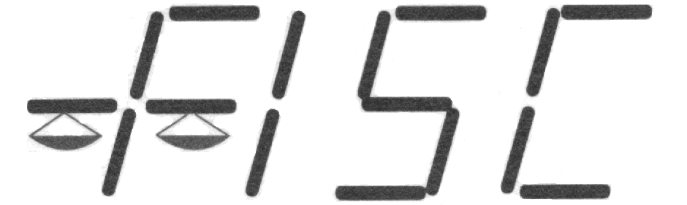
Florida Industrial Scale Co.
728 Industry Road
Orlando FL 32750
(800)-330-7972

Longwood (407) 331-7972
Clearwater (727) 524-1099
Jacksonville (904) 778-0047
West Palm (561) 844-7177

Calibrations • Consulting •Rentals
Sales • Certifications • Repairs

Calibration Estimate
Name: | Date:
Address: | Contact:
City/State: | P.O. #:
FISC Rep: Jef Frost | Email:
Number of Calibration Visits: | Start Calibration:
Scales to be calibrated per visit:
Brand | Model | Serial No. | Capacity | Type/Remarks

Price per Calibration Visit:

- We will inspect and perform minor adjustments on the above list of scales
On a timely basis, as required during normal working hours when we are in the area
- No work other than regular calibration will be done without approval.
- You will be billed only after calibration is completed.
- Unless noted, testing will be performed using class “F” certified test weights.
- Handbook 44 tolerances will be the basis to perform scale adjustments.

The term of this agreement is one year from date and from year to year thereafter, unless terminated by either party by written notice to the other at least 30 days prior to the end of the term. Additional equipment will be automatically included under this policy by appropriate notation and payment of same, unless otherwise specified at the time of purchase.

ORDER APPROVED BY: | _________________________________ | TITLE:  ______________ | DATE: ____________________
PRINT NAME: | _________________________________ | ________________

Florida Industrial Scale Co.
What is Scale Calibration?
How Often Must I Calibrate?
F. I.S.C. recommends quarterly calibration of most scales.
Factors to consider when deciding on frequency of calibration:
- Is the scale operating in a hostile environment?
- How often is the scale being used? Is it used for one; two or three shifts or is used only several times a week?
- Are there any quality control parameters such as U.S. Government or ISO 9000 that must be maintained?
- How long can your company afford to have a scale in use that is out of calibration and is shipping too much or too little product?
- How long can your company afford to receive shipments with a scale that may be out of calibration?
- Many times, after a history of a particular scale’s performance in regard to maintaining calibration is documented, the frequency of inspections can be reduced.

Added Benefits to Regular Calibration Customers!
- Regular calibration customers receive a reduced hourly service rate.
- Your equipment spends minimum time out of calibration.
- Scales on a regular inspection and calibration program require less emergency calls.
- Peripheral equipment such as printers are regularly checked for defects along with the scales.
- Cost of diagnoses and repair of your scales is significantly reduced because our technicians are familiar with your equipment and we have a record of your equipment and it's operating history.
- Customers with calibration agreements are moved to the highest priority when service is required.
Serving Central and North Florida over 38 years with

Offices in Longwood, Lakeland, Jacksonville and West Palm Beach
Why is Calibration Needed?
- All new scales must be calibrated when first placed into service at a customer’s location.
- Any scale will, in time, drift away from its original calibration. Wear of mechanical components, age, and degree of use will all contribute to calibration drift.
- The State of Florida requires that any scale used to sell a commodity or service must be inspected and certified as to its accuracy.
F.I.S.C. Inspects and calibrates some scales as often as every month, some every two months, every three months, every six months and some only once a year. Please allow us help find the program that is right for you.
For a free estimate for an Inspection and Calibration program for your operation, please call:
Calibration of a scale is a procedure whereby a technician uses known test weights that are certified by the State of Florida Bureau of Weights and Measures to adjust the response of an electronic or mechanical weighing device during the following tests:

- The indicator must display "zero" when there is no weight on the scale.
- When known weight is applied to the scale, the indicator must display the amount of applied weight within prescribed tolerances.
- When known weight is applied or removed incrementally from the scale, the indicator must display weight equal to that on the scale within prescribed tolerances.
- The scale must display the same weight without regard to where the weight is placed.
1-800-330-7972

